Introduction
Dear participant, thanks for joining the evaluation of the universAAL Reference Model.
Please read carefully the definitions below and answer some few questions at the end of each section and at the end of the document.
You can add your comments in whatever form (Word comments, added text, etc.), and we will be very thankful for your suggestions at all levels.
Consider that we are mainly evaluating the following aspects of the Reference Model:
- The quality of its description: are the used words the correct ones? Is the use of the language good enough? Are the descriptions simple to understand?
- How much the model is representative of the Ambient Assisted Living (AAL) domain: does this model cover all the aspects that are worth mentioning about AAL? Is there any important concept or relationship that we have missed?
But please feel free to introduce whatever aspect you consider interesting.

The total amount of time for reading and answering the questions should not exceed one hour.
We hope you will enjoy.

The universAAL Reference Model
The agreed definition for a reference model in universAAL is: “A reference model is an abstract framework for understanding significant relationships among the entities of some environment. It enables the development of specific reference or concrete architectures using consistent standards or specifications supporting that environment. A reference model consists of a minimal set of unifying concepts, axioms and relationships within a particular problem domain, and is independent of specific standards, technologies, implementations, or other concrete details.” [1]
A Reference Model is relevant to:
- create standards for both the concepts that inhabit the model and their relationships to one another
- break down a large problem space into smaller problems that can be understood, tackled, and refined → Developers who are new to a particular set of problems can quickly learn what the different problems are, and can focus on the problems that they are being asked to solve, while trusting that other areas are well understood and rigorously constructed
- improve communication between people
- create clear roles and responsibilities
- allow the comparison of different things: e.g., how well each of the candidate solutions can be configured to meet the needs of a particular business process
The Reference Model for AAL is formalized by using concept maps [3]. Concept maps propose an approach for knowledge representation similar to semantic networks that build semantic relations among concepts through a directed or undirected graph consisting of vertices, which represent concepts, and edges. One of the benefits of using concept maps is that the work can start with less formal constraints, increase (if required) the formalism gradually and eventually ends up with the formalism of ontology. Furthermore, even they can apparently be considered just a simple tool, concept maps are a very expressive and powerful way for defining and representing knowledge. Simple relations or complex knowledge environments can be provided by using concept maps.
The graphical representation of concepts and their interrelationships within concept maps are assumed to help different types of stakeholders to quickly learn about the understanding of the AAL domain based on which universAAL started to work. The set of concept maps representing this understanding do reflect the major concepts of the input projects.
In order to structure the AAL domain, an ordering of the concepts was worked out by first putting the smallest set of concepts that could reflect a basic understanding of AAL systems in one concept map serving as the root map, and then organizing the rest of the concepts in a set of subordinate concept maps that provide more details in different directions at a second level. Some remarks should help to better interpret the concept maps before starting to present them in the following subsections:
- Top-level concepts are drawn as ovals and the second-level concepts as rectangles.
- Reuse of top-level concepts in the related second level maps indicates the connection between the latter maps and the root map.
- Different colors are used to further group the concepts and add some traceability across the concept maps.
- Bold lines and fonts are used to highlight concepts of special importance.
- Exemplary concepts are connected by dashed lines and are not meant to be comprehensive. They are not part of this reference model, but should help to better understand a related main concept.

The Root Concept Map
The root concept map (Figure 2) presents the consolidated understanding of AAL domain in a single picture using the fewest possible set of concepts. Details about the concepts in the root concept map are presented in further sections as concept maps providing more precise definition for the related terms. All of them contain one or more concepts from the root concept map, with the corresponding color code, as a linking point. In this way it is evident, how the root map and the detailed concept maps relate to each other.
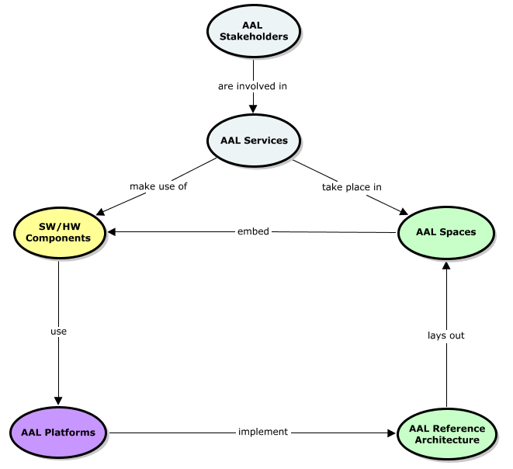
Figure 2: The Root concept map of AAL domain

AAL Stakeholders | Stakeholders of the AAL domain e.g. service providers, end users, authorities etc.
AAL Service | A service composed as a combination of software, hardware, and human resources to support well aging of assisted people.
AAL Reference Architecture | A reference architecture that models the abstract architectural elements (building blocks) in the AAL domain.
AAL Platforms | A set of hardware and software artifacts (standardized and compliant with the AAL Reference Architecture) that help the end users to offer their contribution during the life cycle of the AAL Service.
AAL Spaces | Environments where people may need assistance (e.g.: homes, airports, railway stations, supermarkets and cars) with defined boundaries of hardware, software , and human resources in the context of e.g. access control, multimodal user interfaces etc.
Hardware/Software Components | A collection of software and hardware components used as a support in the process of provisioning of AAL Service from providers to users.

The AAL domain is all about the provision of AAL Services to end users (e.g. Assisted Persons and/or Caregivers). It is realized thanks to the usage of ambient technologies in the provision process of such services which is highlighted by the presence of the concept of AAL Spaces and the underlying Hardware and Software Components the AAL Reference Architecture and the compliant AAL Platforms represents the engineering challenges of modular and interoperable infrastructures. The AAL Reference Architecture identifies the basic building blocks necessary for constructing an AAL Space which in turn represents logical boundaries between hardware, software, and human resources needed for provisioning of particular services.
The AAL Services which take place in an AAL Space make usage of Hardware and Software Components embedded in it. The cooperation between such distributed components in an AAL Space is facilitated by an AAL Platforms that implement the previously mentioned AAL Reference Architecture in order to provide for resource sharing and let users experience an integrated world easy to interact with based on natural communication. In fact all concepts on Root concept map are experiencing the strong influence of AAL Stakeholders, however in order to make it more readable only their involvement, as both benefactor and beneficiaries, in AAL Services is presented.

Questions and comments:
Please share with us some opinions about this concept map:
Q1: Do you have any suggestion about how to improve the naming of the concepts and/or their definition?

Q2: Do you see any relevant missing concept in this map?

Any further comment is welcome.

AAL Stakeholders
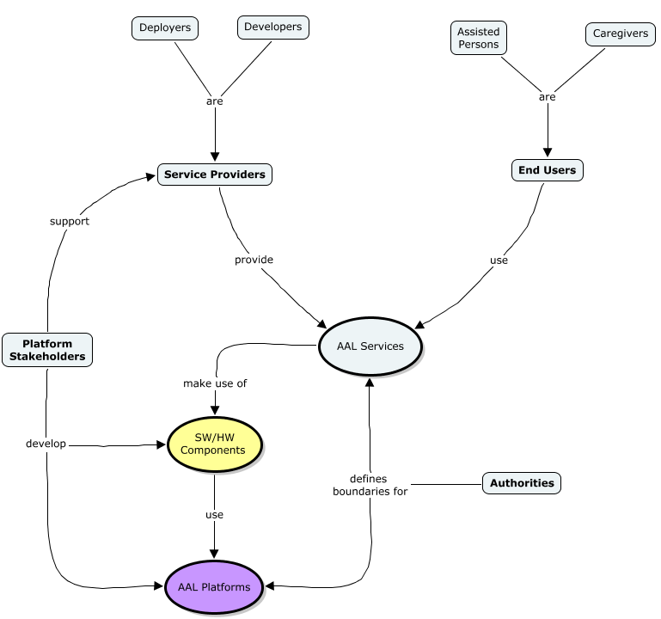
Figure 3: The AAL Stakeholders concept map
End Users | Non-technical group of AAL community members that directly benefits from the AAL Services (e.g. Assisted Persons, Caregivers)
Service Providers | Providers of the AAL Services to the End Users (e.g. Developers, Deployers).
Platform Stakeholders | Technical group of AAL Stakeholders that provide platform components (both hardware and software) used in process of developing AAL Services.
Authorities | Organizations and institutions that work in the economical and legal context of AAL thus having an impact on the overall AAL Domain

Stakeholders of the AAL domain have previously been introduced in such projects as AALIANCE [4]. The key stakeholders of this classification as well as their relationships to concepts of AAL domain are presented in Figure 3.
The main users of AAL technologies who are also the beneficiaries of such solutions are as follows: the elderly, people lacking in certain abilities, and their informal caregivers. We use the term Assisted Person to point out that everyone may need assistance, not only elderly. The Caregivers are understood as people from Assisted Person personal network such as friends, neighbors, and relatives, or professional caregivers. The concept of End Users is used to indicate that these two categories of stakeholders are the main group which requires and uses AAL Services.
The organizations that provide services to the main target group (i.e. security-service providers, care-service organizations, shopping services, transport services, delivery services, social services, community centers, etc.) are referred as Service Providers. In this category we include: Deployers - people in charge of equipping the environment with ICT technology, and installing the needed software to run the AAL Service; Developers - implement AAL applications by using the services offered by a platform; Formal Caregivers - offers their human resources to support the process of providing the AAL Service.
All industries and companies that supply goods and services to the Service Providers are referred to as Platform Stakeholders. In this category we include: Hardware Developers - producing devices and sensors; Software Developers - implement AAL Platforms and software services used by developers from Service Providers category. The main difference between two of them is that Service Provider developers uses the software framework of AAL platforms to realize AAL Applications while the others develop the AAL platforms itself.
The organizations and institutions that work in the economical and legal context of AAL are presented as Authorities. They are regional and national agencies working for the social-security, welfare and healthcare system, policy makers, and authorities in general. They are important in the AAL landscape to overcome the barriers and boundaries related to the AAL domain.

Questions and comments:
Please share with us some opinions about this concept map:
Q1: Do you have any suggestion about how to improve the naming of the concepts and/or their definition?

Q2: Do you see any relevant missing concept in this map?

Any further comment is welcome.

AAL Services

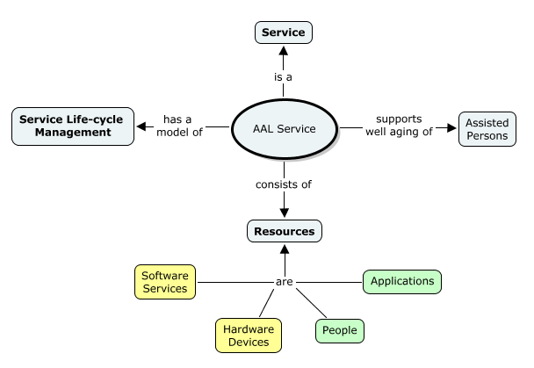
Figure 4: The AAL Service concept map

Service | A process of providing the consumer with some added value offered by provider in accordance with agreed contract.
AAL Service Life-Cycle Management Model | Model describing the possible operations that can be done to manage the life-cycle of AAL Services. Includes such processes as: Acquisition, Provisioning, Utilization, Removal etc.
Resources | A set of compounds which can be used in the provision process of an AAL Service to end users (e.g. software services, hardware devices, people, applications)

The AAL Service (Figure 4) is defined as a Service from the business point view. During the provisioning process of the AAL Service any combination of following resources may be involved: software services – software components which enable data processing and communication activities; hardware devices – enable the possibility of sensing and actuating the area in which Assisted Persons lives; people – real-life value offered by specific Caregivers; applications - software components that has an user interface and was chosen by the End User to be run on its device. The main idea of AAL Service is to support well aging of Assisted Persons. As every service, the AAL Service itself has its own Service Life-cycle Management model.

Questions and comments:
Please share with us some opinions about this concept map:
Q1: Do you have any suggestion about how to improve the naming of the concepts and/or their definition?

Q2: Do you see any relevant missing concept in this map?

Any further comment is welcome.

AAL Service Life-cycle Management
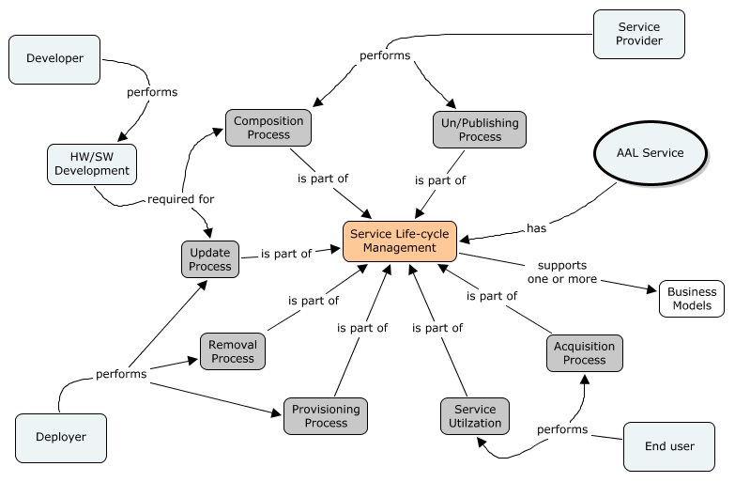
Figure 5: The AAL Service Life-cycle Management concept map

Development of SW Component | Creation of the software part of an AAL Service.
Composition and Publishing | Process of combining interoperable resources into a functional entity, the AAL Service, and submitting it to a public media to be accessed by the AAL Community. The Composition deals with conflicts and dependencies resolution of the used resources. The Publishing deals with placing the AAL Service in the repository and its presentation to the AAL Community – defining terms of use, price etc.
Acquisition | Process of obtaining the rights to use an AAL Service. It includes concluding a contractual relationship between End User and Service Provider or payment of a fee (the price of AAL Service). This could be done by the End User (Assisted Person) or someone acting in his behalf (Caregiver)
Provisioning | Process of delivering the service resources to the End User and making them operable. It includes deployment of the software components onto End User’s runtime platform(s), their configuration and customization. If the AAL Service consists of the hardware components they are also delivered, connected and configured to operate with the runtime platform(s) of the End User’s.
Utilization | Process of direct use of the AAL Service by the End User.
Removal | This process is opposite to the Provisioning. It includes removal of the software parts of the AAL Service from the runtime platforms of the End User and takes care for returning the rented hardware equipment to its owner. As a result any contractual agreement between End User and Service Provider of the AAL Service being removed is made void.
Unpublishing | Process of withdrawing of the AAL Service from the Repository. It could be triggered by the Service Provider providing the AAL Service, a public Authority or the operators of the said repository.
Update | Process of delivering changes of the AAL Service to the End User. It includes development and provisioning of software components, replacement of defected or malfunctioning hardware equipment, changes of the terms of involvement of the human resources etc.

The Service Life-cycle Management (SLCM) model describes the processes related to creation of an AAL Service, its delivery to the assisted person, utilization and removal. It supports one or more Business Models. This section presents the overall description of the individual processes and points the involvement of the different stakeholders. The main concepts and key relations related to SLCM are shown as a concept map in Figure 5

As described previously, the AAL Service is a composition of multiple resources. The development of software and hardware components is performed by Developers. The resulted components are typically market, published on the web and in software repository. Software components are described with metadata: some additional information, like a description, conditions of use, requirements and dependencies, license agreement etc.
The role of the Service Provider is to perform the Composition and Publishing Process; that’s the act of collecting, publishing and marketing interoperable resources into a functional entity, the AAL Service. The Service Provider in turn provides additional information describing terms of use, requirements, payment options and price, contact data etc.

The Acquisition of AAL Service is the process in which the End Users declare his interest to a specific AAL Service and express his consent to the terms and conditions of use (i.e. usage agreement). He may enter into contractual relationship with the provider of this AAL Service and, if necessary, pay the price entitling him to obtain and use the Service. On other side, if stated in the usage agreement, the Service Provider may be bound to provide the service, update and support it.

As result of the Acquisition, the AAL Service is delivered to the end user. This is done by the Provisioning process. This is the process where the software component of the AAL Service is deployed in the AAL Space of the End User, configured and initialized; the hardware components (if any) are delivered, configured and made available in the AAL Space; the Human Resources (if any) are introduced to the End User. This process is performed by a Deployer, who also demonstrates the use of the AAL Service to the End User.

After the successful Provisioning of the AAL Service the End User can start using it. This is the process of Utilization. In some cases the Utilization is bound to the charging (determining what should be paid) and payment of the service, as stated in the Usage agreement.

Important part of the Service Lifecycle Management is the process of modification and Update of a Service. This includes update of the conditions of use, update of the software part (related to the subsequent Provisioning of the updated component), replacement of devices or human resources. These changes could be done with or without the explicit consent of the End User. The Development of the updated software component is done by a Developer and the actual Update may require the involvement of a Deployer.

The final part of the Service Lifecycle Management is the process of Removal of the AAL Service from the AAL Space. This includes de-installation of the installed software components from the AAL Space, return of the any borrowed hardware and end of the contractual relationship between End User and Service Provider.

The Service Provider can withdraw his Service from the market. This is done by Unpublishing the Service from AAL Public Repositories. Thus the Service is no more available to the end users. The Unpublishing can trigger Removal of the Service from the End User’s premises and thus discontinue the support provided by the Service Provider. The legal effects of this action are out of the scope of this document.

Questions and comments:
Please share with us some opinions about this concept map:
Q1: Do you have any suggestion about how to improve the naming of the concepts and/or their definition?

Q2: Do you see any relevant missing concept in this map?

Any further comment is welcome.

AAL Spaces

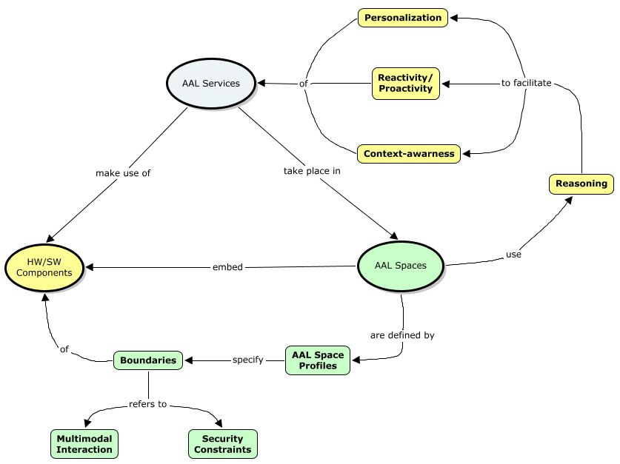
Figure 6: The AAL Space concept map

Reasoning | Using context information for facilitating software parts of AAL Services with advanced ambient features such as:  - context-awareness (e.g., inferring and adding new information to context),  - personalization (e.g., deducing users' situational preferences),  - reactivity (e.g., learning from behavior analysis),  - pro-activity (e.g., analysis of correspondence between situations and needs)  for the needs of AAL Services.
Context-awareness | The capability of AAL Space to extract or modify information about the current state of its runtime environment.
Personalization | The capability of AAL Space to incorporate knowledge about characteristics, capabilities, and preferences of each individual human user interacting within its boundaries.
Reactivity | The capability of AAL Space to automatically react to occurrence of certain situations in an adaptive way.
Pro-activity | The capability of AAL Space to automatically perform actions that are anticipatory and aim at getting prepared for future situations.
AAL Space Profile | Description of AAL Space which contains: definition of mandatory and/or optional software and hardware components as well as attributes of AAL Space.
Boundaries | A set of limitations which are specified for particular software and hardware components embedded in AAL Space
Multimodal Interaction | Performing the interaction with the End Users using multiple channels in parallel, possibly with a hybrid mix supporting different modalities (e.g. voice, gestures, graphical user interface etc.)
Security Constrains | Access control constrains specifying which resources (software, hardware, human) are capable of performing interaction in the boundaries of particular AAL Space.

The AAL roadmap released by the AALiance project characterizes AAL in the following way [4]:
“AAL has firstly to be distinguished from more traditional forms of (ICT enabled) assistive technologies by emphasizing the important role of ambient intelligence in AAL technologies”
According to that definition the role of AAL Spaces in the AAL domain is a very important aspect. The concept of AAL Space is used to facilitate deployment of advanced ambient functionalities (like Personalization, Reactivity/Proactivity, and Context-awareness) for supporting AAL Services which take place in them. Furthermore, each AAL Space is defined by a set of AAL Space Profiles which define boundaries of Hardware and Software Components embedded in such space. These boundaries refer to e.g. Security Constraints or Modality Mechanisms which are defined in particular AAL Space.
The concept of AAL Space Profiles is introduced to facilitate the standardization of the typical environments where people may need assistance: homes, airports, railway stations, supermarkets and cars to name few examples. The standardization itself is out of the scope of this document and it is a concern of industrial forums that can better define market boundaries and product opportunities. From developers point of view standardization helps to define the target environment and the kind of services and devices the developed application can expect to interact with. For example a nutritional advisor service can be specified for the home space profile and with difficulty it will be specified for a car space profile.

Questions and comments:
Please share with us some opinions about this concept map:
Q1: Do you have any suggestion about how to improve the naming of the concepts and/or their definition?

Q2: Do you see any relevant missing concept in this map?

Any further comment is welcome.

Software and Hardware Components

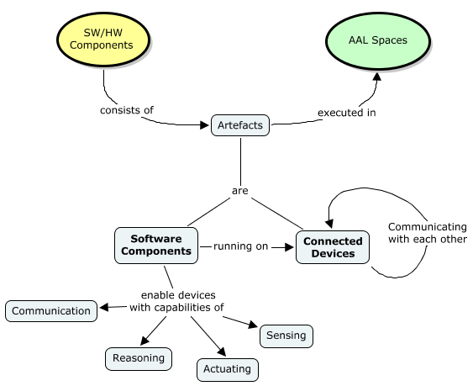
Figure 7: The Software and Hardware Components concept map

Connected Device | A device with capabilities of performing communication with other devices. May embed other atomic devices like actuators (devices that can cause changes in the physical world e.g. manage the lights in the room etc.) or sensors (a device that realizes a sensing channel by capturing info from the physical world).
Software Components | A piece of software that can be run on Connected Device. Depending on the software functionality as well as the device on which it is run may enable hardware with features such as Communication, Reasoning, Sensing, or Reasoning for the purpose of AAL Services.

The concept of Software and Hardware Components (described in Figure 7) represents the significant role of both software and hardware elements in the AAL domain. These artifacts are executed inside of AAL Spaces in accordance with particular spaces profiles and boundaries defined by them. Furthermore, Software Components are running on Connected Devices providing them with such features as: Communication, Reasoning, Sensing, and Actuating. The exact specification of which Software Components (and for which Connected Devices) should be embedded in AAL Space is specified directly by AAL Space Profile. By using profiles Software and Hardware Developers do not need to know the actual configuration of the final installation, and development tools can automatically provide the set of specific software packages for the profile they are targeting.
Questions and comments:
Please share with us some opinions about this concept map:
Q1: Do you have any suggestion about how to improve the naming of the concepts and/or their definition?

Q2: Do you see any relevant missing concept in this map?

Any further comment is welcome.

AAL Platforms
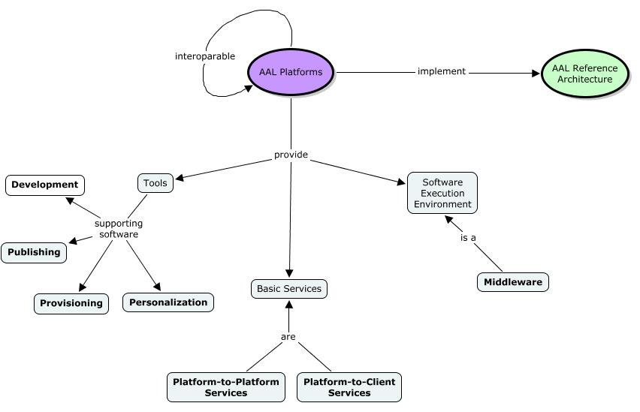
Figure 8: The AAL Platforms concept map

Development Tools | Tools supporting the software developer during the process of developing software artifacts (AAL Platforms itself as well as AAL Services).
Deployment Tools | Tools supporting the Deployer to perform tasks related to the deployment of the AAL Services into AAL Space (installation, configuration, customization, update and removal).
Community Tools | Tools that provide facilitates for publish, provisioning, search, discover or manage AAL software.
Personalization Tools | Tools for configuration and adjustment of the AAL Services to the specific needs and preferences of the individual End User (Assisted Persons or Caregivers).
Platform-to-Platform Services | Services that are provided by one platform stakeholder to another (e.g. a web service provider requires remote data from a remote database service provider).
Platform-to-Client Services | Services that are provided by a platform stakeholder to End Users or AAL Services Developers (e.g. a web service provider offers a remote configuration service to an end user’s smart kitchen).
Middleware | An example of Software Execution Environment that ranks among the core of platforms for distributed systems and is responsible for  - the integration of software components distributed on different nodes and  - facilitating the communication among them.  For this purpose, it must hide both the distribution of the system and any possible heterogeneity of its nodes.

Figure 8 presents the concept map containing basic concepts describing the AAL Platforms. The platforms promoted in this document implement the AAL Reference Architecture. The AAL Platforms communicate with each other in order to provide platform specific functionalities valuable to the AAL Stakeholders.

One type of the AAL Platforms is a Developer Support Platform which provides and promotes a standardized set of tools to support the end users when offering contribution to the overall AAL process. For the Developers the AAL Platform offers tools for modeling, implementation, testing and promoting their AAL Applications. These could include extensions to existing IDE (Integrated Development Environment) such as Eclipse or IntelliJ IDEA. The Deployers will find tools helping them to install, configure and manage the AAL Services, locally or remotely. The AAL Platforms provide tools for personalization of the AAL Services and their adjustment to the specific needs and preferences of the individual Assisted Persons.

Another category of AAL Platforms is AAL Community Support platform which offers platform to support this community. This platform enables the sharing of AAL Applications and AAL Services among the Stakeholders, helps regulating the business relations between Stakeholders and helps the delivery (deployment) of the AAL Services from the remote repository to the target platform for consumption by the end users.

The last one of AAL Platforms is AAL Runtime Support Platform. It implements the AAL Reference Architecture by providing of the needed infrastructure enabling the operations of the AAL Services dealing with the specific needs of the Assisted Persons. This infrastructure offers a collection of Basic Services either in form of Platform-to-Platform or Platform-to-Client services. They realize a number of key platform features (discovery and pairing of devices, abstraction of device implementation specifics, handling of context information, service brokerage, manageability, security, service lifecycle and many others) as specified by the AAL Reference Architecture.
The AAL Services are supposed to be installed and run on one or more intelligent devices in the vicinity of the Assisted Person in some Software Execution Environment. An example of such environment is an AAL Middleware that provides a unified runtime environment for execution of the AAL Services, abstraction of the platform’s hardware and OS specific, sharing functionality among platforms etc.

Questions and comments:
Please share with us some opinions about this concept map:
Q1: Do you have any suggestion about how to improve the naming of the concepts and/or their definition?

Q2: Do you see any relevant missing concept in this map?

Any further comment is welcome.

Reference Architecture
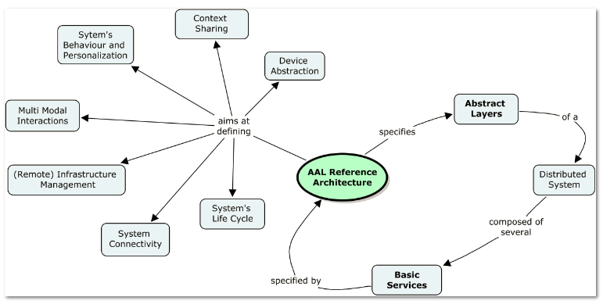
Figure 9: The AAL Reference Architecture concept map

Abstract Layers | Contains description of core elements of AAL Reference Architecture called AAL Building Blocks. They are functional entities providing some key functionality specified by the architecture like discovery and pairing of devices, abstraction of device implementation specifics, handling of context information, service brokerage, manageability, security, service life-cycle and many others.
Basic Service | A software component implementing one or more AAL Building Blocks.
This section describes the AAL Reference Architecture which is the architecture model for a class of ICT-based systems used in the AAL domain. It reflects the AAL business domain in the form of ICT architectures in technological agnostic way. The AAL Reference Architecture focuses on generic concepts, mechanisms, and paradigms of ICT in order to solve real-world AAL domain issues. Furthermore, it is described in such a way as to facilitate the realization of proposed concepts in form of specific technological solutions.
Figure 9 presents the concept map of AAL Reference Architecture. It specifies a set of Abstract Layers which altogether define a Distributed System of AAL domain. Such Distributed System is composed of several Basic Services specified by the AAL Reference Architecture. Those Basic Services offers core system functionalities like security, communication, data storage etc. as well as system common elements like domain model, configuration structure etc. However, the main of the goals of the AAL Reference Architecture is to define the basic building blocks which characterize the platform supporting AAL domain such as: device abstraction, system connectivity and life-cycle, context sharing etc.
More detailed information about the AAL Reference Architecture can be found in Part III of the D1.3 version D.

Questions and comments:
Please share with us some opinions about this concept map:
Q1: Do you have any suggestion about how to improve the naming of the concepts and/or their definition?

Q2: Do you see any relevant missing concept in this map?

Any further comment is welcome.

Final questionnaire
The following is a questionnaire that is related to all the Reference Model in general, please answer these questions:

Q1: How do you think that the universAAL reference model succeeds in being an abstract model consisting of a minimal set of unifying concepts, axioms and relationships within the AAL domain? Please justify your answer.

Q2: Could you imagine a model that is “more minimal” than this? What would you cut?

Q3: Are there concepts, axioms or relationships from the AAL domain that you feel are missing in the model?

Q4: What did you particularly like about the model?

Q5: What did you particularly dislike about the model?

Q6: Please rate the general quality of the document, in terms of language and readability

Assertion | I agree | I somewhat agree | I somewhat disagree | I disagree
I think the language is simple and understandable
I think the language has the right level of formality for its scope
I think that I will remember this model in the future

Any other further comment is warmly welcome.

References
- Web Services Glossary, W3C Working Group Note 11 February 2004 http://www.w3.org/TR/2004/NOTE-ws-gloss-20040211/
- Berners-Lee T., Hendler J., and Lassila O., The SemanticWeb. Scientific American, vol. 284, no. 5, 2001, pp. 34 – 43.
- Novak, J. D. & A. J. Cañas, The Theory Underlying Concept Maps and How to Construct Them, Technical Report IHMC CmapTools 2006-01 Rev 01-2008, Florida Institute for Human and Machine Cognition, 2008", available at: http://cmap.ihmc.us/Publications/ResearchPapers/TheoryUnderlyingConceptMaps.pdf.
- G. Van Den Broek, F. Cavallo and C. Wehrmann, Ambient Assisted Living Roadmap, Volume 6 Ambient Intelligence and Smart Environments, IOS Press, 2010 - from AALIANCE FP7 project ( www.aaliance.eu)

